Task 1 Outputs
CREATE DATABASE BankDB;
USE BankDB;
CREATE TABLE bank_transactions (
txn_id INT PRIMARY KEY,
customer_name VARCHAR(50),
branch_name VARCHAR(50),
transaction_type VARCHAR(20),
amount DECIMAL(10,2),
transaction_date DATE
);
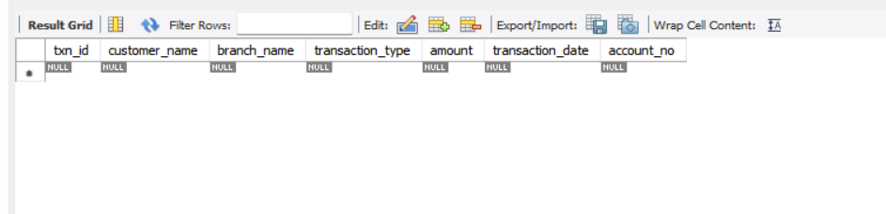

ALTER TABLE bank_transactions
ADD account_no VARCHAR(20);
ALTER TABLE bank_transactions
MODIFY customer_name VARCHAR(100);
RENAME bank_transactions TO customer_transactions;
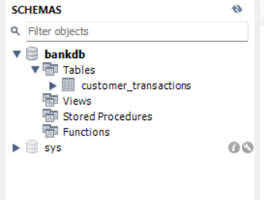

TRUNCATE TABLE customer_transactions;
CREATE TABLE bank_backup AS
SELECT * FROM customer_transactions;
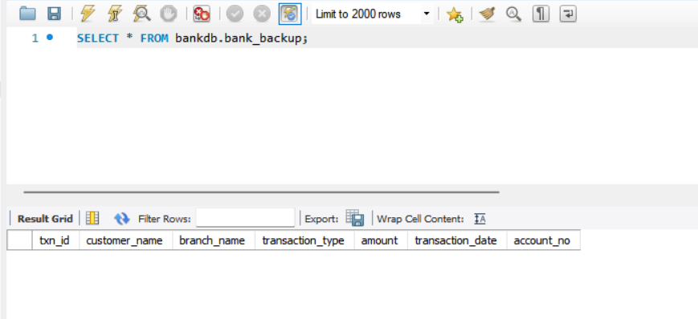

DROP TABLE bank_backup;
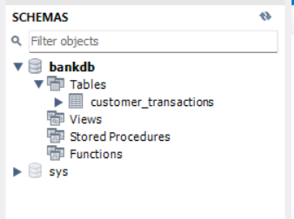

INSERT INTO customer_transactions
VALUES
(101, 'Prem Sai', 'Hyderabad', 'Deposit', 5000, '2026-01-05', 'ACC1001'),
(102, 'Sai Kiran', 'Hyderabad', 'Withdrawal', 2000, '2026-01-06', 'ACC1002'),
(103, 'Rahul', 'Vijayawada', 'Deposit', 12000, '2026-01-08', 'ACC1003'),
(104, 'Arjun', 'Vizag', 'Deposit', 8000, '2026-01-10', 'ACC1004'),
(105, 'Priya', 'Hyderabad', 'Withdrawal', 3500, '2026-01-11', 'ACC1005'),
(106, 'Varun', 'Vizag', 'Deposit', 15000, '2026-01-12', 'ACC1006'),
(107, 'Keerthi', 'Vijayawada', 'Withdrawal', 1000, '2026-01-13', 'ACC1007'),
(108, 'Vamsi', 'Hyderabad', 'Deposit', 9000, '2026-01-14', 'ACC1008'),
(109, 'Sneha', 'Vizag', 'Withdrawal', 4000, '2026-01-15', 'ACC1009'),
(110, 'Manoj', 'Vijayawada', 'Deposit', 11000, '2026-01-16', 'ACC1010');
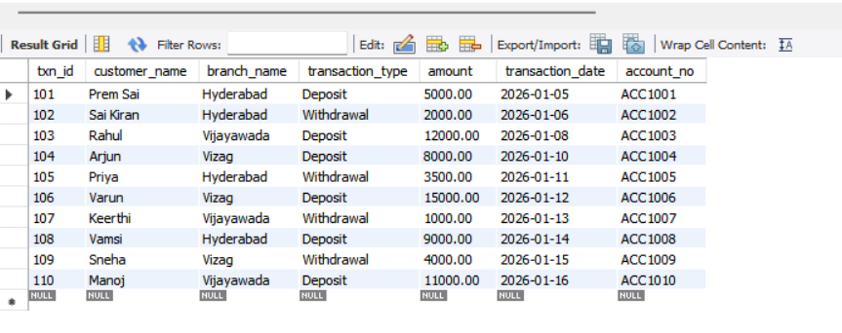

INSERT INTO customer_transactions
VALUES
(111, 'Prem Kumar', 'Vizag', 'Deposit', 7000, '2026-01-18', 'ACC1011');
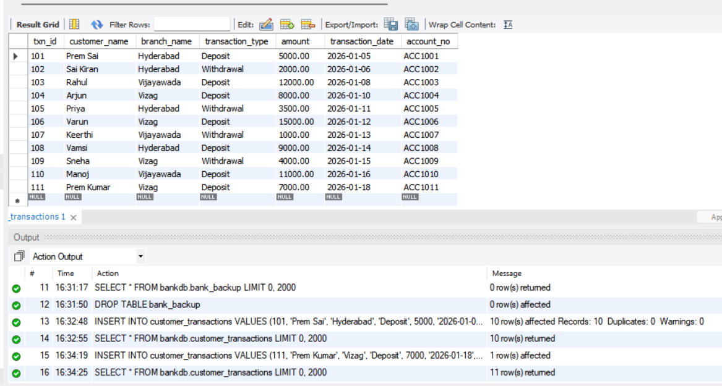

UPDATE customer_transactions
SET amount = 5000
WHERE txn_id = 105;
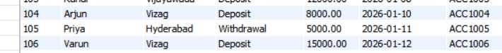

DELETE FROM customer_transactions
WHERE txn_id = 111;
SELECT *
FROM customer_transactions;
SELECT *
FROM customer_transactions
WHERE transaction_type = 'Deposit';
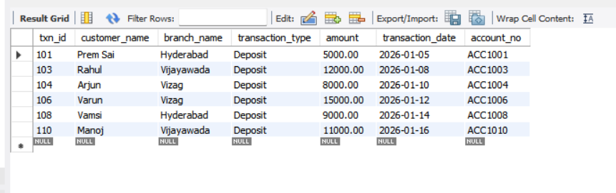
SELECT *
FROM customer_transactions
ORDER BY amount DESC;
